Accessibility Tools and Guidelines in Canvas

By Lene Whitely-Putz and Angela Drum, @One

Web pages, HTML, and Rich Content Editors
One common feature amongst CMSs is the ability to create a single web page. We can use these pages to create content for our course, including our syllabus, policies, introductions to units, unit content, and a host of other material.
Computer programmers and professional website designers use HTML--Hypertext Markup Language--to create websites, but online instructors do not have to be HTML wizards to build beautiful and accessible websites. Instead, we use Rich Content Editors to create these pages. The text editor allows people who do not have coding experience to create professional-looking webpages. Magic. Unfortunately, without a background in web design, teachers inadvertently use the text edit tools (or fail to use the tools!), creating web pages that raise havoc for assistive technology.
In this chapter, we'll explain the Universal Design for Learning (UDL) guidelines that support the development of accessible web pages. There is no reason to reinvent the wheel, however. Before we get started, please carefully review the following White Paper from 3PlayMedia, paying particular attention to pages 11-13:

Focus on Pages
Though the 2015 Roadmap covers a broad array of accessibility issues, in this chapter, we're going to focus solely on designing web pages, called "Pages" in Canvas, using the Rich Content Editor. First, let's discuss the stakeholders. Web pages are often not accessible to the visually impaired, color blind, and blind. In addition, web pages can be confusing and even cause seizures for people with cognitive differences.
To meet the needs of visually impaired or blind students, we need to understand the Assistive Technology they use, screen readers and screen magnifiers. Screen readers convert written text to audio, allowing people with visual impairments to listen to information on the web, surf the web, and shop on the web in ways similar to sighted users. That said, the screen reader is not a human with cognition.
Sighted users can skim a web page, using visual cues, images, links, titles, and paragraph markers to jump from point to point. Sighted users make decisions about what they want to read, and the order in which they read. Skimming a page allows readers to build a cognitive framework for the information they will read. When skimming, readers note key ideas and create a loose hierarchy of important points in their short-term memory. Skimming can pique their interest, which also enhances engagement.
Screen readers, though very fast, are linear, reading content from top to bottom. Users can, however, use keyboard commands and settings to skim through content, emulating the experience of a sighted person. Screen readers use cues embedded in the html code of the webpage to find headers, links, the start of paragraphs, and images. However, when web pages do not follow accessible html style guidelines, these cues may be missing. The absence or misuse of the html code disrupts the screen reader, resulting in a tedious and sometimes confusing experience for the user.

Miscues between technologies are not the only errors, however. Sometimes, in an effort to be creative and visually appealing, instructors design a page that is visually inaccessible. We may misuse colors, use funky fonts, or use other design elements.

Toolbar Functions
Anyone familiar with WORD or other document creation software could probably figure the Rich Content Editor in no time. The problem is not that it is hard to use—it may be that it is too easy! Because we are familiar with the tools, we may use them in ways that are not compliant with accessibility guidelines. Let's make a quick run through the toolbar.

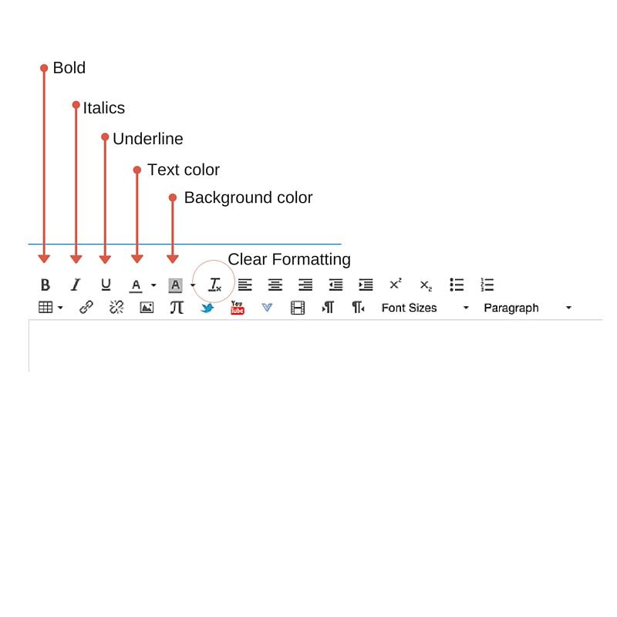
From the top left of the toolbar, here are the functions:
- Bold—should be used to emphasize text, and can be used in conjunction with color. Most often misused as a way to mark a header.
- Italics—should be used to emphasize text or for the title of a book, journal, or magazine.
- Underline—may be sparingly used for emphasis, but is commonly used to draw attention to hyperlinked material.
- Text Color—should be used sparingly, with attention paid to contrast between the background and the text.
- Background Color/Highlight—should be used sparingly, and when used, should maintain sufficient contrast between text and background color.
- The circled "Tx" clears formatting—a great way to ensure you are not importing formatting code from another document when copying and pasting.
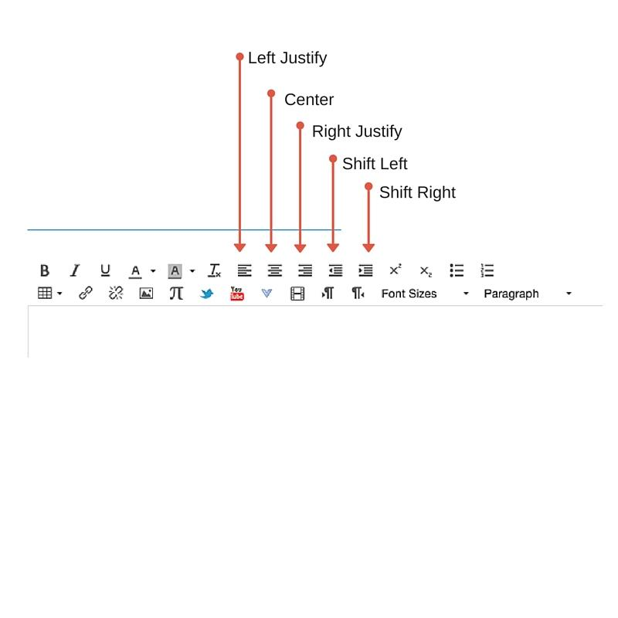
- Left Justify—aligns text and images to the left margin
- Center—Centers text and images
- Right Justify—aligns text and images to the right margin
- Shift Left—decreases indentation
- Shift Right—increases indentation

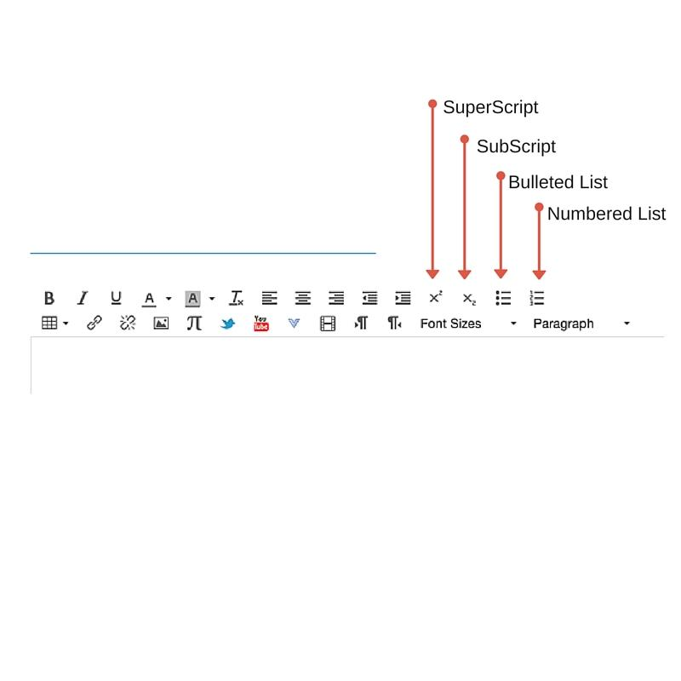
- SuperScript—Reduces font size and shifts character to the exponent position, for abbreviations like 1st
- SubScript—Reduces font size and shifts character to below the baseline, such as used for chemical compounds H₂O
- Bulleted List—formats items in a list. The coding sees all the items in the list as a group, and provides uniform formatting for the group.
- Numbered list—formats items in a list with numbers instead of bullet points. All items in the numbered list will be seen as a single group.

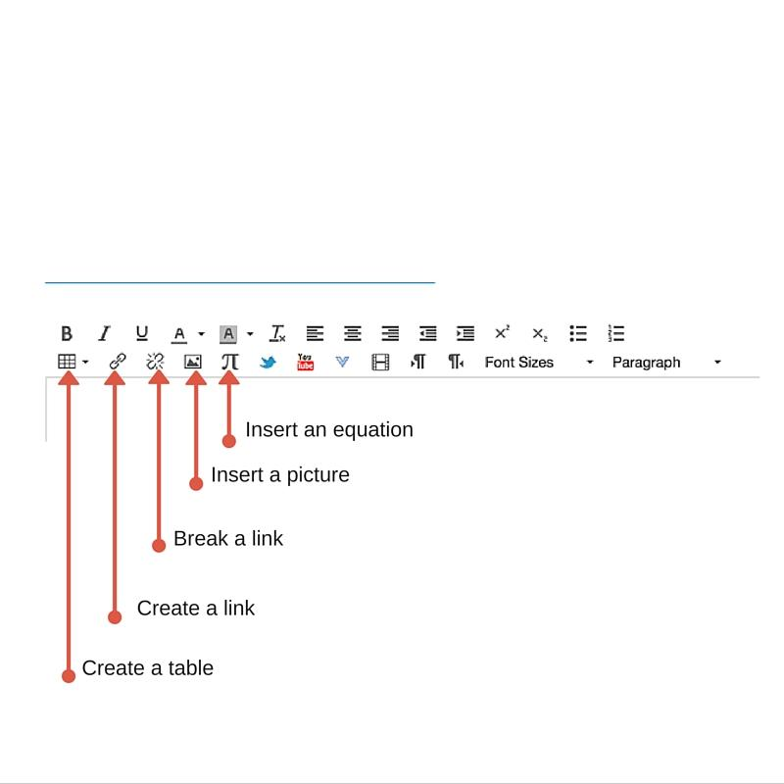
From the bottom left:
- Create a table—allows you to insert a table
- Create a link—allows you to make any text or image into a hyperlink
- Break a link—allows you to undo a link, returning text or images to 'normal'
- Insert a picture—allows you to insert an image, size the image, and title the image, called "alt text"
- Insert an equation—allows you to insert mathematical symbols

Format and Styles
- We now know that misusing a formatting tool causes problems for screen readers, and misguided use of styles can result in low contrast or busy pages that cause problems for people who are colorblind or those with low-sight. Your natural reaction might be to stop using any fancy formatting, but this over-correction might just send you careening off the other side of the road!
- Instead, there are a few guidelines you should follow to create excellent, visually appealing web pages. The first involves the skeleton of your site--your headers--and paragraph styles.
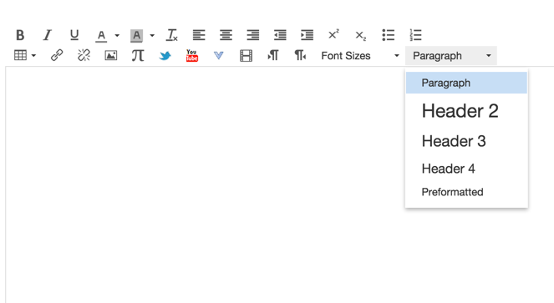

- Sighted users skim the pages for headers. The size of the font, the color of the font, and any styles (bold, underlined, or italicized, for instance) give visual cues to the reader that the words are headers. Sighted readers are pretty good at picking headers out. Screen readers, however, don't use visual cues to pick out headers, they use the html code. If your method for creating a header is to highlight the text, make the font bigger, and add bold, you have not created a header, you've simply created big words with emphasis. This may work for a sighted user, but not for a student using a screen reader!
- Instead, to make a header, highlight the text and use the Rich Content Editor's paragraph tool to properly format the header. Be sure to use the correct level of header, too, first level 1, then level 2, then level 3, and so on. As you can see here, Canvas forces you to start at level 2. This is because the title of your page is automatically formatted with a level one header. Follow the same rules you would if you were creating an outline:
- Heading 1

- Heading 2
- Heading 3
- Heading 3
- Heading 2
- Heading 2
- Heading 3
- Heading 3
- Heading 4
- Heading 4
- Notice in this example the only singleton is Level 1. All other headers should be in pairs or more. The basic framework of header levels provides the overarching structure that allows a user of a screen reader to efficiently navigate your site.
- For back ground on html and more information on formatting your pages, see the WebAim tutorial, Semantic Structure.

Links
The beauty of a web page is being able to connect your students to other sites on the information highway, and rich content editors make creating these links easy--simply highlight the words you want to turn into a hyperlink, and select the link tool. Be careful, though, about the phrase you choose as your link. When screen readers come to a link, most tell the user they have reached a link by announcing "link." If you've also included the word "link" in your hyperlink, this could lead to unnecessary repetition that interfere with the users ability to listen to the reader.
In addition, users often use links to skim through a site. Because of this, linked text should be concise, informative, unique, and make sense out of context. You want to avoid, for instance, using "here" or "Click here" as a link:
For more information on X, look "here"
As the user skimmed through the links, the only information the screen reader would be able to give them is, "Link. Here" "Link. Here" "Link. Here" Not very helpful, right?
Similarly, don't use a URL as a link. The user will be forced to listen as the screen reader reads out "Link. https//www.thisisthelongestlinkinthehistoryofeducation/0n00n.xfghtlwm.dirlthm/"
Whew!
For more information on creating links within your text, see WebAim's series of articles on linking, Links and Hypertext.

Tables
You might be tempted to skip over this discussion of tables, thinking you rarely use them, but if you use rubrics, you use tables!
When a screen reader comes to a table, it moves through each cell, left to right, top row to bottom row. This is not helpful to a student who is looking for information in a specific cell, right? To help your student navigate the table, you need to use the text editor to code the header row.

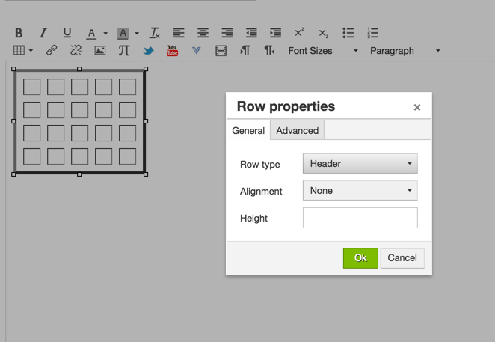

Rows, columns, and cells can also be color-coded. If you choose to use color, be sure there is sufficient contrast between the background color and the font.
Lastly, think about your visually impaired student who is using a screen magnifier. When you set the Table properties (this is not the same as row properties), set the width and height in percentages, not pixels. This will allow the table to scale to the window size, which has an added benefit for your mobile device users, too! The example below limits the table to 50%--that was randomly chosen, not a recommendation! For more information on tables, see the WebAim tutorial, Creating Accessible Tables.

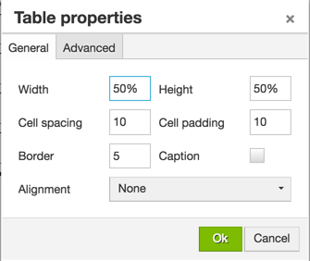

Colors and Fonts
As mentioned, color is an important visual aid. It draws the eye, denotes emotion, and creates visual appeal. When used well, it can help emphasize key points. Color can do wonderful things, but it can cause issues, as well! Here is a short video to illustrate the issues you may encounter with color:

Accessibility Tutorial — Color from M. Ricardo Flores on Vimeo.

If we can't go crazy with color, we might be tempted to use fonts to texture our pages. This, too, can be a slippery slope. First and foremost, use real text versus images. Though it might be tempting to use screen shots of words, images can become pixelated when magnified, essentially becoming illegible to anyone using screen magnifiers.
In general, it is recommended that you use fonts that work well on the web (3PlayMedia recommends Arial, Georgia, or Verdana). Be careful when playing with font sizes—going too small may affect many users, and multiple fonts types or sizes may make for visual chaos.
WebAim has excellent resources for checking color contrast.
For an extensive discussion of fonts, see WebAim's article on Fonts.

Images
Images, like color and fonts, can provide visual interest to our pages, break up blocks of text, and stimulate visual learners. Certain maps and illustrations bear witness to the idiom, a picture is worth a thousand words. Like other elements in our webpage designs, however, they should be included with intention. In general, you should use images that are clear enough for web display, but not so large they slow down the loading of the page. Avoid using images to replace text or as links, and avoid animations, which are distracting, and blinking images, which can, in rare cases, cause seizures.
There are two other important points to consider when working with images. First, screen readers don't see what you see. In order to convey the image to the user, a screen reader needs you to describe the image. This is done in special html code called "alt text." Because alt text is an important component of accessibility, most CMSs provide a dialog box for noting alt text when you insert an image. Let's take a look at the image insertion tool in the Canvas Rich Content Editor. When you choose the insert image tool, this window opens:

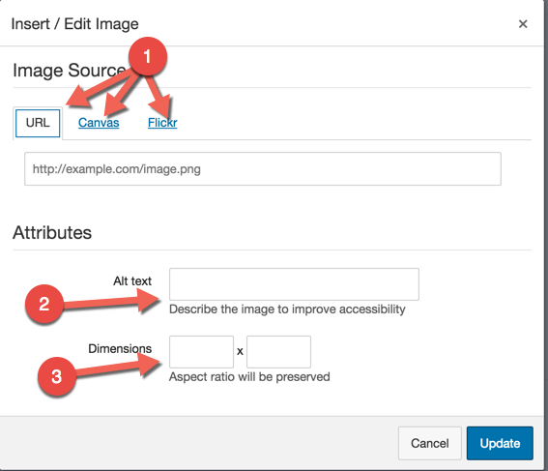

As the three arrows next to the number 1 illustrate, Canvas allows you to choose your image from one of three different sources, an image URL, your Canvas files, or Flicker. In addition, as the arrow labeled number 2 illustrates, you are asked to include Alt Text (Canvas adds, "Describe the image to improve accessibility"), and as arrow number three points out, to size the image. Let's choose Flicker as our image source.
When you choose this option, you will be given a search bar to narrow your choices. We used the search term "information highway." Several interesting images were found.
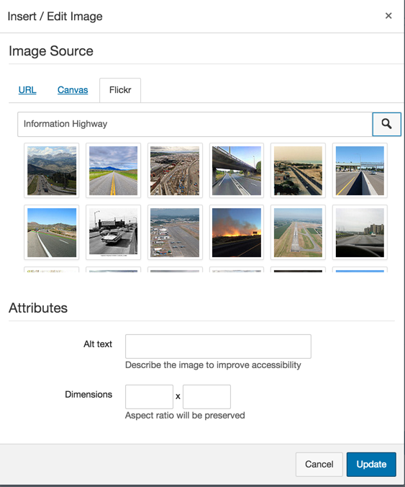

When you select an image, the alt text field is automatically filled in with the title of the image—though this may seem helpful, this is a problem! Let's take a closer look to see why:
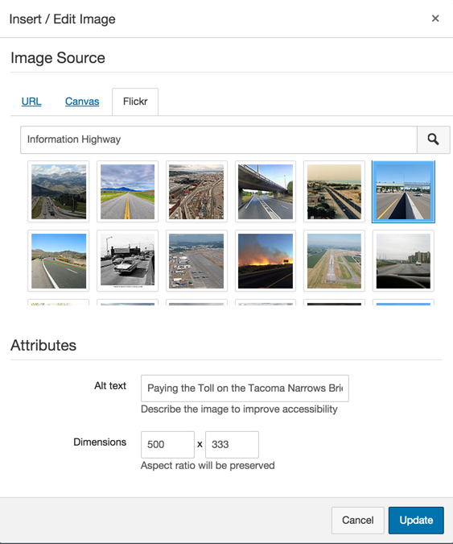
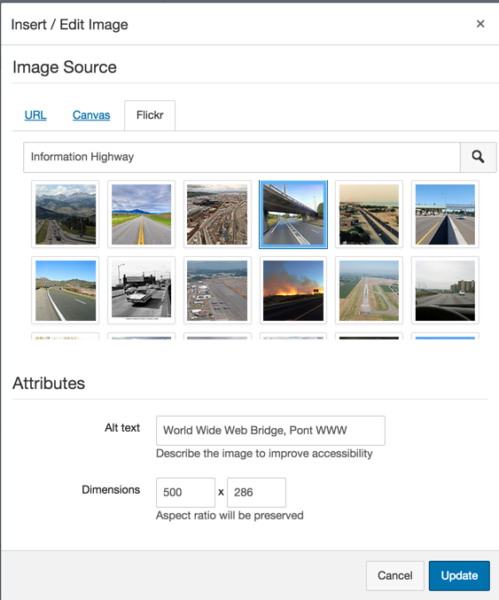

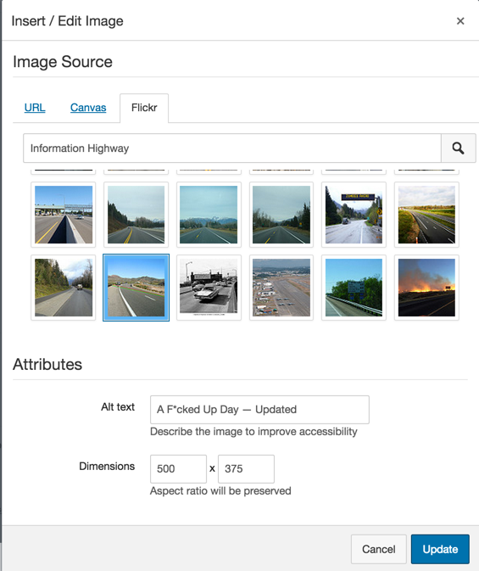

As you can see from the three images, the file names vary widely, and none of them have much to do with the search term, Information Highway. In addition, if you look closely at image #3, you may be surprised by the alt text that was "automatically" entered.
The moral of the story is, you should write the alt text that goes with your image, as only you know the message you are trying to convey to your students. The alt text should clearly and concisely explain the image, in context.
Alt text is important. Please take a moment

Summary
Creating an instructional web page is fun and rewarding, and it is easy to make it accessible if you build in accessibility from the ground up! Here's a quick checklist to set you on the right path:
- To support screen readers, provide structure for your page by using headers
- Be sure all tables have header rows
- Avoid overusing bold, italics, or underlining
- Use color judiciously, and be sure text has sufficient contrast with the background
- Use a clear, legible font, such as Verdana, Arial, or Georgia
- Provide concise but descriptive alt text for images

Additional Resources
WebAim's WCAG 2.0 Checklist
Section 508 Checklist
WAVE Accessibility Evaluation Tool
Chrome Alt Text Extension
Chrome WAVE Extension

